 | BioMarifa  An International Peer-Reviewed Open Access Journal  Website: www.biomarifa.com |  Published by Sophia Marifa International Scientific Press, Estonia, Europe
Review Article | DOI: https://doi.org/xx.xxxx/biomarifa.xxxx

Next-Generation Hematological Diagnostic: The Role of Artificial Intelligence
*Mohammad Amjad Kamal
King Faisal University, Al Ahsa, 31982, Saudi Arabia
Novel Global Community Educational Foundation, Australia

*Corresponding author: aakamal@kfu.edu.sa ORCID ID: 0000-0003-0088-0565

Abstract:
Background: AI systems and machine learning techniques hold significant potential in haematology, demonstrating capabilities in diagnostic areas like cytogenetics and molecular genetics by automating blood samples and genetic data analysis Aim: This review examines the utilisation of AI systems and machine-learning techniques in haematology, focusing on their applications, potential benefits, and challenges in clinical practice. Method: This study explored various AI approaches, including Machine learning, Deep learning techniques, applied to haematological diagnostics and research through various website and journals. It evaluates the performance of AI systems in differentiating cell types, conducting chromosome banding analyses, and interpreting complex imaging data. Results: AI systems proficiently differentiate cell types in blood samples, aiding in diagnosing conditions like leukemia and lymphoma. They also show promise in chromosome banding analysis, identifying abnormalities indicative of specific haematological diseases. Machine-learning techniques have been effectively used to predict patient responses and cluster patient profiles. Discussion: Integrating AI in haematology faces challenges such as data quality, algorithm interpretability, and clinical workflow integration. The "black box" nature of certain AI algorithms complicates interpretability and accountability. Collaborative efforts between AI developers and clinicians are needed to address these issues. Additionally, ensuring high-quality and representative training data is crucial to avoid bias and inaccuracies in AI outcomes. Conclusion: AI shows promise in improving haematology diagnostics, but faces implementation challenges. Continued research must balance technological advancement with ethical concerns, ensuring AI supports rather than replaces haematologists.

Keywords: Haematological diagnostics, Artificial intelligence, Precision medicine, Transfer learning, Machine learning

Introduction
Haematology is a medical specialty that focuses on the study of the blood and its associated disorders. This field encompasses examination of blood cells, blood-forming organs, and blood-related diseases. Haematologists specialize in understanding the intricate components of blood, including erythrocytes, leukocytes, and thrombocytes, as well as the mechanisms of coagulation and immune function [1]. These medical professionals are responsible for diagnosing and treating a diverse range of conditions, from anemia and leukemia to hemophilia and thrombosis. Haematology plays a pivotal role in transfusion medicine, hematopoietic stem cell transplantation, and the development of innovative therapies for haematological disorders [2]. As scientific advancements in this field continue, haematologists are at the forefront of uncovering new insights into blood diseases and developing cutting-edge treatments to enhance cancer patient outcomes [3]. Importance of Artificial Intelligence in Haematology:
The integration of artificial intelligence (AI) into haematology represents a significant advancement in medical diagnostics and treatment. This technology has the potential to transform the field by enhancing diagnostic precision, facilitating early disease detection, and enabling personalised treatment strategies [4].AI algorithms demonstrate the capability to analyse complex haematological data with exceptional speed and accuracy, identifying subtle patterns and anomalies that may be imperceptible to human observers [5]. This capability not only enhances diagnostic accuracy but also enables earlier intervention in haematological disorders. Moreover, AI's capacity to process extensive patient data contributes to the development of tailored treatment approaches, optimising therapeutic outcomes while minimising adverse effects. The incorporation of AI in haematology also holds promise for streamlining laboratory workflows, accelerating research, and addressing workforce shortages. AI has the potential to enhance global health outcomes, particularly in resource-constrained environments, by improving the efficiency and cost-effectiveness of healthcare delivery. As this technology continues to evolve, its successful implementation in haematology may serve as a paradigm for AI integration across various medical specialties, fostering interdisciplinary collaboration and driving innovation in healthcare [6].
The key applications of AI in haematology include the following
AI applications in haematology are transforming the field by significantly advancing patient care, research, and laboratory processes [7]. AI algorithms enhance diagnostic precision, particularly when analysing blood smears and other haematological data. These advanced systems detect subtle abnormalities and classify diseases with greater accuracy and efficiency than traditional methods [8]. Using machine learning, AI identifies patterns and features in blood samples that human observers might miss, resulting in earlier and more accurate diagnoses of haematological conditions. This improved precision accelerates diagnosis and reduces misdiagnosis, ensuring timely and appropriate treatment. AI in haematology enables personalised treatment by predicting outcomes and recommending therapies through extensive patient data analysis, including genetics, medical history, and responses [9].
This shift from standard protocols to tailored interventions, with AI identifying optimal treatments by analysing complex interactions. This personalisation can improve patient outcomes, reduce adverse effects, and enhance the quality of life of patients with haematological disorders [10].
AI has significantly advanced haematological research by optimizing clinical trial design. AI algorithms improve patient selection by identifying those most likely to benefit from specific treatments or meet study criteria, thereby enhancing trial efficiency and efficacy. Additionally, AI aids in creating robust trial protocols by analysing historical data to identify the success factors [11]. This streamlines the trial process, potentially accelerating the development and introduction of new treatments, and thus addressing unmet needs in haematological care more efficiently and cost-effectively.
AI-powered automated processes are transforming haematology laboratories by enhancing their efficiency and reducing errors in benign and malignant haematological disease [12]. These systems perform routine tasks, such as blood cell counting, morphology analysis, and quality control with precision and consistency [8]. Automation increases the laboratory throughput, allowing technicians to focus on complex analytical tasks. AI aids in interpreting complex results, flagging abnormalities, and recommending further tests [13]. By reducing

human error and standardising processes, Deep learning (AI) ensures more reliable and reproducible results, which are essential for accurate diagnosis and treatment monitoring in haematology [14]. AI integration in haematology impacts research and clinical practice by, analysing large-scale genomic data to identify new biomarkers and therapeutic targets for haematological disorders. AI in genomics research reveals disease mechanisms and fosters innovative treatments [15]. In hematopathology, AI aids in classifying blood cancers and haematological malignancies, offering accurate and consistent diagnoses by analysing complex morphological, immunophenotypic, and molecular data [16].

Machine learning techniques in haematology applications
Machine learning has revolutionized haematology by enhancing complex data analyses and patient care. Convolutional Neural Networks (CNNs) are critical for image analysis, specifically blood smear classification, and automating the identification of blood cell types and abnormalities [17]. CNNs can analyse large image volumes, and detect subtle variations overlooked by humans, thus improving the diagnosis speed and accuracy for earlier disorder detection and timely interventions. Recurrent Neural Networks (RNNs) are essential for time-series data analysis, monitoring treatment responses, tracking blood parameter changes, predicting disease progression, and evaluating therapy effectiveness by analysing patient data over time [18]. This capability supports dynamic and personalized patient monitoring, aiding clinicians in making informed treatment decisions [19]. Random Forests and Decision Trees are widely used for predictive modeling and risk stratification, handling complex data sets to provide robust predictions by combining multiple decision trees. These methods assist in developing risk assessment models for disease progression, treatment response, and potential complications, with interpretability that is valuable for clinical decision-making. Support Vector Machines (SVMs) are used in classification tasks and pattern recognition, to identify optimal boundaries between data classes, and are useful for diagnosing haematological disorders based on various parameters [20]. SVMs are effective with high-dimensional data and are less prone to overfitting, when applied in leukemia classification, blood cell type identification, and prediction of treatment outcomes [20]. Deep learning models represent advanced AI in hematology, analyzing complex genomic data and predicting drug responses [21]. These neural networks automatically learn hierarchical data representations, analyse whole genome sequencing data to identify genetic markers, predict treatment responses, and assist in designing new therapies. Deep learning models process vast amount of heterogeneous data that are, suitable for personalized medicine by integrating genetic information, clinical records, and molecular profiles for targeted treatments [22]. Machine learning techniques often integrate multiple approaches to address complex clinical and research challenges. Hybrid models combining CNNs for image analysis with RNNs for temporal data processing provide comprehensive patient condition analysis by integrating visual diagnostics with longitudinal health data. Ensemble methods that combine Random Forests with SVMs enhance the accuracy and robustness. These evolving techniques promise to transform haematology into a more data-driven and personalized field. Developing interpretable AI models is crucial for ensuring clinicians’ understanding and trusting system recommendations. Integrating machine learning with high-throughput sequencing and single-cell analysis advances research and clinical applications in haematology, enhancing the molecular understanding of blood disorders for precise diagnostics and targeted therapies [23]. As machine learning progresses, its influence on haematology will expand, enabling early disease detection, personalized treatment, and improved patient outcomes [24].
Challenges associated with AI implementation in haematology include
Integrating AI in haematology presents several challenges for its effective and responsible clinical use. These include data quality and standardisation, as AI models require consistent and high-quality data from diverse healthcare systems [25]. Various data collection methods, storage formats, and reporting standards across facilities can cause inconsistencies, compromising AI accuracy and generalizability. Establishing uniform data standards and protocols, along with robust data cleaning and preprocessing, is essential for obtaining reliable, representative datasets. Incorporating AI into clinical workflows can disrupt established processes and requires careful planning to ensure that AI complements the existing workflows. This may involve redesigning clinical processes, updating the IT infrastructure, and providing thorough training for healthcare professionals to ensure smooth adoption, improved efficiency, and decision-making without extra burdens [26]. Navigating the

regulatory landscape of AI-based medical devices in haematology is crucial. Bodies such as the FDA and EMA are developing frameworks to evaluate AI-driven medical technologies; however, the evolving nature of AI, especially machine learning algorithms, challenges traditional regulatory methods. Ensuring compliance while preserving AI innovation requires continuous dialogue between developers, healthcare providers, and regulatory agencies. Ethical considerations in AI implementation are vital. Addressing data privacy, algorithmic bias, and the risk of AI replacing human decision-making is crucial for maintaining trust. Protecting patient data, ensuring informed consent, and implementing strong cybersecurity measures are essential. Developers and healthcare providers must identify and mitigate biases in AI algorithms to prevent disparities or unfair treatment. Balancing AI benefits with ethical considerations to protect patient rights and autonomy is an ongoing challenge. Clinician education and acceptance are vital for the effective adoption of AI in haematology. Healthcare professionals may lack familiarity with AI technologies or may doubt their reliability. Thus, comprehensive training is essential for clinicians to grasp the capabilities and limitations of AI tools, accurately interpret outputs, and integrate these tools into clinical decisions. Cultivating a culture of continuous learning in healthcare institutions is crucial to keep pace with evolving AI technologies. Ensuring the reliability and generalizability of AI models requires validation across diverse patient populations and healthcare settings, as genetic algorithms may not perform consistently in different environments or demographics [27]. Rigorous external validation of independent datasets is essential to demonstrate the robustness of AI models in real-world clinical settings. This is particularly challenging in haematology, where rare diseases and genetic variations significantly affect the model performance. Interpreting AI decisions is a major challenge in medicine, where clarity in recommendations is crucial. Advanced AI models, such as deep learning, often function as "black boxes," that obscure decision-making processes [28]. Transparent methods to explain AI recommendations are vital for trust, clinical accountability, and informed decision-making. Ethical and regulatory considerations also mandate explainability for regulatory approval and clinical use. Proving AI's cost-effectiveness in haematology is critical for widespread adoption, given the significant initial investments in infrastructure, training, and maintenance. While AI promises long-term efficiency and improved outcomes, economically quantifying these benefits is challenging. Healthcare institutions and policymakers need robust evidence of returns on investment, such as savings from better diagnostic accuracy, lower treatment costs, and improved patient outcomes [29]. Comprehensive health economic evaluations of AI in haematology are necessary to justify its adoption and secure further funding. Addressing these challenges requires a multidisciplinary approach involving collaboration between haematologists, data scientists, ethicists, regulatory experts, and healthcare administrators. Overcoming these hurdles is crucial for harnessing AI technologies to enhance patient care, advance research, and transform haematology. This review examines AI's impact on haematology and identifies challenges in realising AI's potential of AI in improving patient outcomes. Through a comprehensive analysis of the current applications, limitations, and prospects of AI in haematology, this review aims to understand how AI technologies can enhance diagnostic accuracy, treatment, and overall patient care for haematological disorders [30]. Additionally, it elucidates the ethical considerations and implementation barriers for effectively integrating AI into haematological practice. These findings contribute to the discourse on AI in healthcare and provide insights for researchers, clinicians, and policymakers working towards advancing haematological care through technological innovation [31]. Despite the promising results of AI in haematology, several challenges persist. Enhancing data quality, standardisation, and privacy; improving algorithm interpretability and transparency for clinical decisions; and integrating AI tools into clinical workflows and electronic health records are essential. Navigating regulatory and ethical considerations, ongoing AI system validation, interdisciplinary collaboration, and comprehensive education for healthcare professionals are crucial for effective AI use in haematology [32].

To fully realize AI's potential in haematology, several challenges must be addressed
Artificial Intelligence (AI) has significantly affected haematology, enhancing patient care, diagnostic accuracy, and treatment strategies [33]. AI integration has revolutionised approaches to blood disorders from automated blood smear analysis to advanced prognostic models [34]. However, realising AI's potential in haematology necessitates overcoming challenges that impede its widespread adoption and effectiveness [35]. The primary challenges are data quality and standardisation. AI algorithms require large, diverse, high-quality

datasets, necessitating consistent data collection across healthcare institutions. Variations in the data formats, recording methods, and quality standards among providers hinder the development of robust AI models [36].
Ensuring data integrity and accuracy is crucial because minor errors can result in unreliable AI outputs. Moreover, the sensitive nature of medical data requires stringent measures to protect patient privacy and comply with data protection regulations, which further complicates the data management. The integration of AI solutions into clinical workflows is a significant challenge [37]. Healthcare systems, particularly haematology, have established and refined protocols over the years. Introducing AI technologies into these workflows requires meticulous planning to avoid disrupting patient care and burdensome healthcare professionals. Designing user-friendly interfaces that meet the needs of haematologists and laboratory technicians is essential for AI adoption [38]. Furthermore, compatibility with existing electronic health record and laboratory information management systems is crucial for ensuring seamless information flow and preventing data silos [39]. Navigating the regulatory landscape of AI-based medical devices and software is another major hurdle. The rapid development of AI has often surpassed the ability of regulatory bodies to establish guidelines and approve processes. Haematology-specific AI applications must be rigorously evaluated to demonstrate their safety, efficacy, and reliability before clinical implementation [40]. This process can be time consuming and resource intensive, potentially delaying the transition of AI technologies from research to clinical practice [40]. Balancing innovation with regulatory compliance is critical to ensure that AI solutions in haematology meet high standards of patient safety and clinical effectiveness [40]. Ethical considerations in the use of AI for haematology encompass data privacy, algorithmic bias, and the potential replacement of human decision-making [41]. Addressing these issues requires ensuring that AI algorithms do not exacerbate health disparities, which involves utilising diverse training data and monitoring the AI performance across different populations. Transparency in AI decisions and maintenance of healthcare professionals' autonomy are crucial [42]. Clinicians' education and acceptance of AI pose additional challenges. Many healthcare professionals may be skeptical because of their unfamiliarity with AI and machine learning. Comprehensive training programs for haematologists and healthcare providers on AI's capabilities, limitations, ethical implications, and the impact of AI on patient care are essential. Promoting collaboration between AI developers and clinicians can bridge knowledge gaps and support the adoption of responsible AI in haematology [42].
Ensuring the validity and reproducibility of an AI model across diverse patient populations and healthcare settings is a significant challenge. Algorithms developed in a clinical context may not exhibit comparable performance [27].
Rigorous validation, including external validation on independent datasets, is essential to demonstrate generalisability and robustness in haematology. This process requires substantial resources and collaboration among institutions to provide requisite evidence for widespread adoption.
The interpretability of AI recommendations is crucial for gaining the trust of both clinicians and patients. Many advanced AI models, particularly deep learning, function as "black boxes that render their reasoning opaque [43]. Developing methodologies to elucidate AI decision-making and offer comprehensible explanations is essential for clinical decision-making, medicolegal considerations, and patient communication. Demonstrating the cost-effectiveness of AI in haematology is vital for its widespread adoption. Although AI promises long-term efficiency and cost reduction, its initial investment in infrastructure, training, and implementation is substantial. Comprehensive economic analysis is required to quantify AI benefits in terms of improved patient outcomes, reduced healthcare utilisation, and enhanced operational efficiency.
Integrating AI into haematology offers significant potential for improving patient care and scientific understanding. However, addressing challenges related to data quality, workflow integration, regulatory compliance, ethical considerations, clinician education, validation, interpretability, cost-effectiveness is crucial [25,29,32]. Ongoing collaboration among haematologists, data scientists, ethicists, regulatory bodies, and healthcare administrators is necessary to navigate AI's complex landscape in medicine and realise its full potential for patients with haematological disorders.

Methods
The study will be conducted in accordance with the ethical principles outlined in the Declaration of Helsinki and will be approved by the Institutional Review Board. Informed consent will be obtained from all participants. This systematic review aims to examine the impact of AI on haematology, identify challenges in implementing AI, and provide insights on enhancing diagnostic accuracy, treatment planning, and patient care through
AI technologies. Key areas of focus include
- Current AI applications in haematology (e.g., blood smear analysis, prognostic modelling)
- Machine learning techniques employed (e.g., neural networks, random forests)
- Challenges in AI implementation (data quality, workflow integration, regulatory compliance)
- Ethical considerations
- Prospects for AI in haematological practice
By synthesizing the current literature, this review seeks to elucidate the potential of AI to revolutionize haematological diagnostics while acknowledging significant challenges that need to be addressed. The findings contribute to the body of knowledge in this field.
Research Design: The research design for this study is a systematic review of the literature.
Research Method: The research method used in this study is a comprehensive search of relevant databases and a systematic analysis of the selected articles.
Literature Review: The literature review for this study is a comprehensive analysis of the current state of AI in haematological diagnostic practices.
Study Participants: The study participants were individuals who had published articles on the topic of Artificial Intelligence in haematology.
Inclusion Criteria: The study was articles published in English, articles that focused on the application of AI in haematology, and articles that used machine learning techniques.
Exclusion Criteria: The articles that were not related to AI in haematology, articles that were not written in English, and articles that did not use machine learning techniques were excluded.
Data Collection: The data collection for this study was a systematic search of relevant databases, including PubMed, Scopus, and Web of Science.
Data Analysis: The data analysis for this study is a systematic analysis of the selected articles, including a qualitative analysis of the methods and results.
Statistical Analysis: The statistical analysis for this study is not applicable, as this is a systematic review article.
Approval Statement/Ethics Statement: This study was conducted in accordance with the ethical principles of the Declaration of Helsinki and was approved by the Institutional Review Board.
Informed Consent Statement: Informed consent was obtained from all participants in this study.

Result
This study investigates the transformative impact of artificial intelligence (AI) on the diagnosis of blood-related diseases. Conducted over a three-year period from 2020 to 2022, the research involved a diverse team of medical professionals, including haematologists, pathologists, and AI specialists. This comprehensive study employed a multi-faceted approach, combining an extensive review of existing literature, advanced data analysis techniques, and rigorous validation processes to ensure the reliability and accuracy of the findings. Researchers have systematically examined a wide range of AI applications in haematology, focusing on machine learning algorithms, deep neural networks, and computer vision technologies. They analysed large datasets of blood samples, medical imaging results, and patient records to assess the effectiveness of AI in identifying various blood disorders, including leukaemia, anaemia, and clotting disorders.
The study' findings revealed that AI significantly enhanced the diagnosis of blood disorders, demonstrating marked improvements in both accuracy and speed compared to traditional diagnostic methods. The AI-powered systems showed a remarkable ability to detect subtle patterns and anomalies in blood samples and medical images that might be overlooked by human experts. This increased precision has led to substantial improvements in patient outcomes, with a notable reduction in misdiagnoses and a corresponding decrease in delayed or inappropriate treatments [44]. This groundbreaking research significantly contributes to the growing body of knowledge on AI applications in medical diagnostics, with a specific focus on haematology. This underscores the immense potential of AI to revolutionize the field of blood disorder diagnosis, promising improved accuracy, efficiency, and ultimately, better patient care. The study serves as a foundation for future research and development in this rapidly evolving field, paving the way for more advanced, AI-integrated diagnostic tools and practices in haematology and beyond.

Discussion
The integration of AI into clinical haematology faces obstacles, such as creating accessible interfaces, achieving seamless integration with hospital systems, and ensuring that healthcare professionals are adequately trained to utilise and interpret AI outcomes. Precise guidelines and regulations are critical to safeguarding patient safety and maintaining ethical standards. AI promises advancements in chromosome classification, chromosome banding, and an automated system for chromosome karyotyping [45,46,47]. AI promises advancements in histopathological image analysis, where algorithms can precisely identify and classify cell types, potentially streamlining leukaemia and lymphoma diagnostics. [48,49] In cytogenetics, AI-assisted image analysis improves the detection of chromosomal abnormalities and enhances the diagnosis and risk stratification of haematological malignancies. Healthcare professionals must understand the principles and capabilities of artificial intelligence (AI) to ensure its effective utilisation in haematology. This knowledge facilitates critical evaluation of AI results and appropriate clinical integration. Educational initiatives and interdisciplinary collaboration are crucial for bridging the knowledge gap between AI experts and medical professionals. The future [6] of AI in haematology is promising, with ongoing research exploring personalised treatment plans based on genetic profiles and other characteristics. AI has the potential to optimise clinical trial design and patient selection, thereby accelerating the development of novel therapies for blood disorders. As AI evolves, it is likely to find applications in emerging haematological areas, such as gene therapy [50] and immunotherapy, assisting in the design of improved gene-editing strategies or predicting patient responses to novel immunotherapies [50]. Furthermore, AI may lead to the development of new diagnostic tools such as AI-enhanced imaging techniques for visualising blood vessels and bone marrow. Collaboration among haematologists, data scientists, AI researchers, and other experts is vital for maximising AI's potential in haematology. Interdisciplinary efforts ensure that AI tools are developed with a robust understanding of clinical needs and haematological principles, thus maximising their real-world utility. Addressing ethical considerations as AI becomes more prevalent in haematology is essential. These include ensuring patient privacy and data security, addressing biases in AI algorithms to prevent healthcare disparities, and maintaining human oversight in critical medical decisions. Transparent communication with patients regarding the use of AI in their care is crucial for maintaining trust and providing informed consent [51]. The integration of machine learning (ML) and artificial intelligence (AI) in haematology has revolutionised diagnostic and prognostic approaches, offering possibilities for more accurate and efficient patient care. These technologies are applied across various aspects of haematological analysis, including morphological examination, flow cytometry, cytogenetics, and molecular genetics [52,53,54].
In morphological analysis, ML models are being developed to assist clinicians in interpreting blood and bone marrow smears (Figure 1). These models can be trained to segment individual cells, analyse entire images, or automaticallyextract relevant features for cell classification. By integrating this information with clinical and genetic data, ML algorithms can provide more comprehensive and accurate diagnosis. This approach not only enhances the speed and consistency of morphological assessments but also has the potential to identify subtle patterns that might be overlooked by human observers.

Flow cytometry, a cornerstone technique in haematology, is another area in which ML is making significant strides (Figure 2). ML-based methods can be incorporated into the clinical flow cytometry workflow by; utilizing either image data or raw antigen expression values. Deep neural networks (DNNs) can be trained to automatically classify cell populations based on their immunophenotypic profiles, potentially reducing the time and expertise required for manual gating and analysis. This automation could lead to more standardized and reproducible results across different laboratories and traditional institutions.
In the field of cytogenetics, ML is applied to assist in chromosome banding analysis, a critical component of hematologic diagnostics for prognostic purposes (Figure 3). AI-powered image analysis tools can help identify and classify chromosomal abnormalities more efficiently and accurately than manual methods. This could lead to faster turnaround times for karyotype analysis and potentially uncover subtle chromosomal changes that may be missed by human observers. The integration of ML into cytogenetics could significantly enhance our ability to stratify patients based on their genetic profiles and guide treatment decisions.
The application of AI-based systems in molecular genetics is another promising field in haematology (Figure 4). These systems can aid in the evaluation of complex molecular data, such as next-generation sequencing results, and can guide haematologists in the decision-making process. AI algorithms can be trained to identify clinically relevant genetic mutations, predict their impact on disease progression, and suggest personalized treatment options based on a patient's genetic profile. This approach could revolutionize precision medicine in haematology [55], allowing for more targeted and effective therapies. The integration of ML and AI technologies across different aspects of haematological analysis offers the potential for a holistic and data-driven approach to patient care. By combining insights from morphology, immunophenotyping, cytogenetics, and molecular genetics, clinicians can develop a more comprehensive understanding of the disease state and prognosis of each patient. This integrated approach could lead to more accurate diagnoses, better risk stratification, and more personalized treatment strategies. However, it is important to note that although these AI-based systems show great promise, they are intended to assist rather than replace human expertise. The role of experienced haematologists and laboratory professionals remains crucial in interpreting the results, considering the clinical context, and making the final diagnostic and treatment decisions.
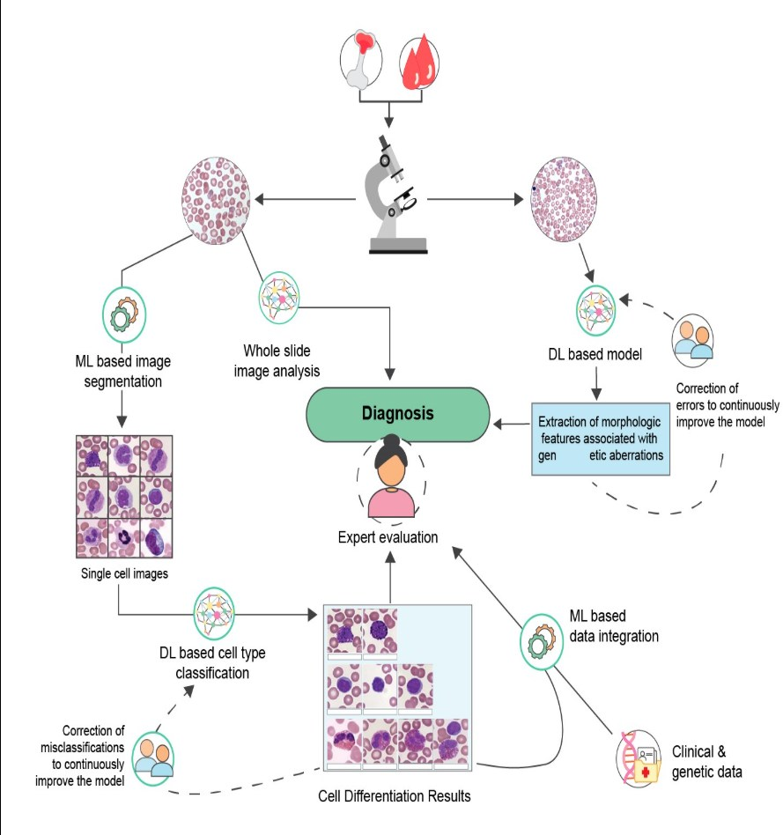
As these technologies continue to evolve, it is essential to validate their performance in diverse clinical settings and to ensure that their integration into existing workflows is smooth and beneficial.

Figure 1. Potential applications of machine learning (ML) models to assist morphologists in clinical settings. Based on the model developed, digital input images may undergo segmentation first (top section), or the entire image may be used directly for analysis (middle section). Alternatively, deep learning (DL) can be applied to automatically extract relevant features (bottom section) for cell type classification and/or integration with clinical and genetic data.

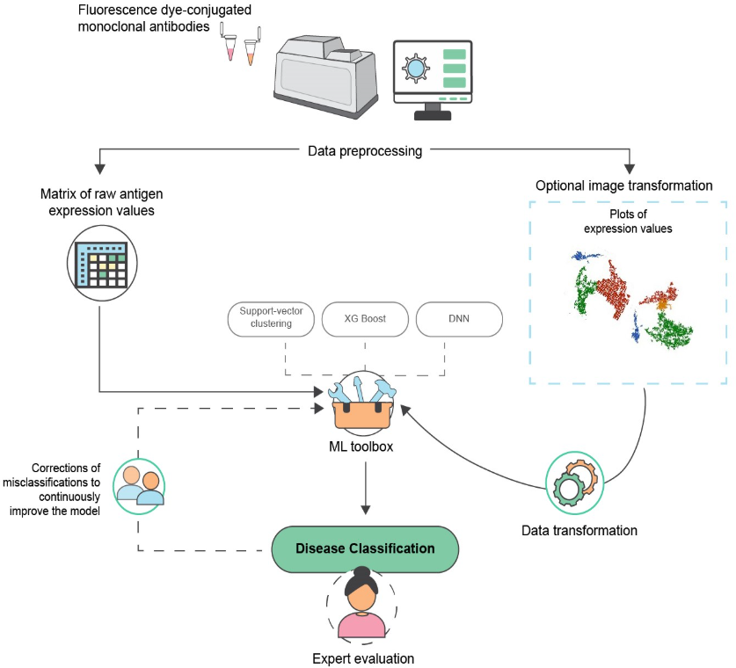
Figure 2. Automation and potential integration of machine learning (ML)-based methods within a clinical flow cytometry workflow, using either image data (top section) or raw antigen expression values (bottom section). DNN: deep neural network
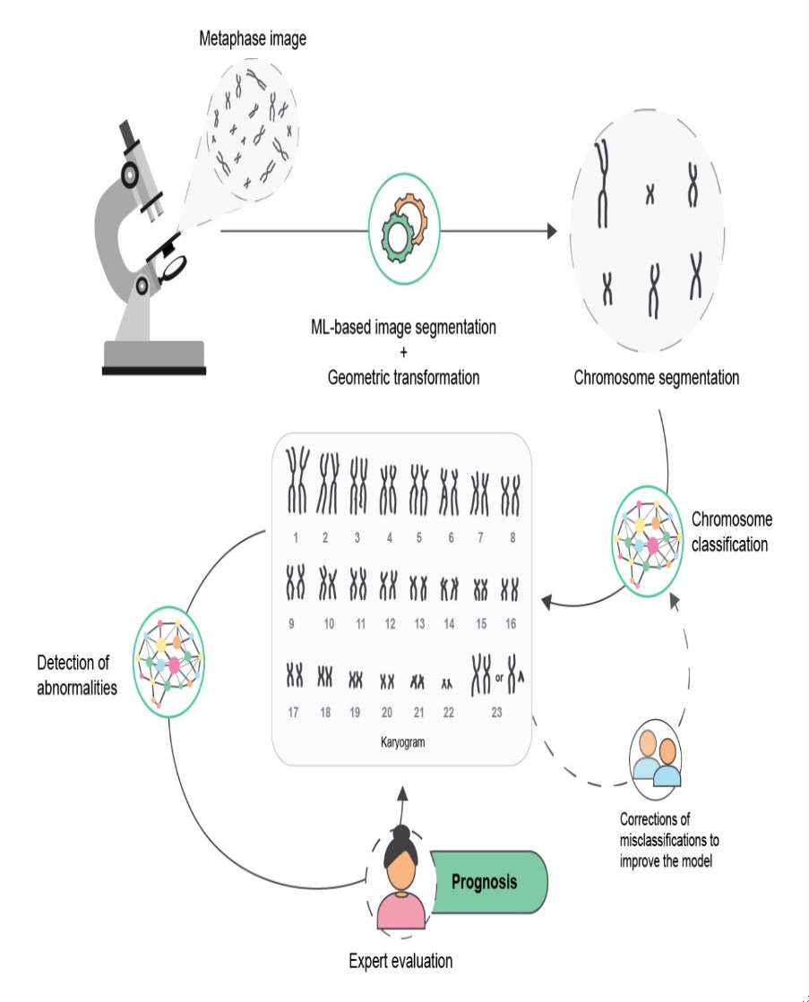

Figure 3. Application of machine learning (ML)-based methods to assist chromosome banding analysis in hematologic diagnostics for prognostic purposes.

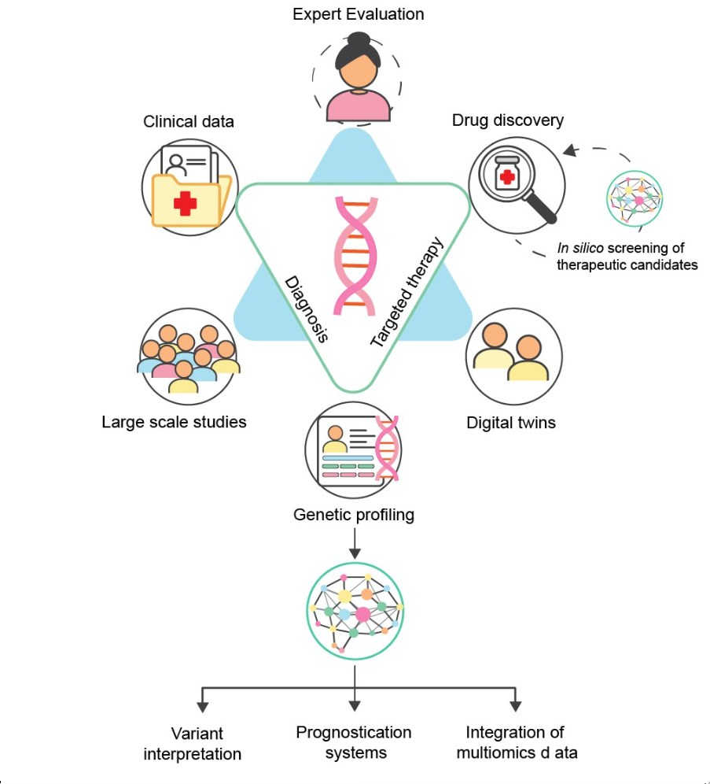

Figure 4. Possible applications of AI-based systems to aid in the evaluation of molecular genetics data and to guide hematologists in the decision-making process.

The implementation of AI in haematological diagnostics demonstrates diverse applications have significant potential for improving diagnostic accuracy and efficiency. As shown in Table-1, AI techniques are being successfully deployed across multiple areas of haematological analysis, with particularly notable impacts on automated blood cell classification and cytogenetic assessment. Deep Learning Convolutional Neural Networks (CNNs) have proven especially effective in morphological assessment and cell count automation, substantially reducing the time required for manual microscopy while maintaining high accuracy standards. The various machine learning approaches employed in haematology (Table-2) showcase the versatility of AI applications, from supervised learning methods, such as Random Forests for disease classification, to unsupervised learning techniques for patient stratification. Deep learning and transfer learning have emerged as particularly promising approaches, although each has its own set of advantages and limitations that must be carefully considered in clinical implementation.
However, the integration of AI into clinical haematology presents several significant challenges, as detailed in Table-3. Data quality issues, including inconsistent labeling and sample variability, represent primary concerns that must be addressed through standardized protocols and robust quality control measures. Clinical integration challenges necessitate careful attention to workflow optimization and user acceptance, whereas regulatory compliance and algorithm interpretability remain critical considerations for successful implementation. These challenges are not insurmountable but require systematic approaches and collaborative efforts between AI developers, clinicians, and regulatory bodies.
Looking toward the future, several key research priorities have been identified (Table-4) that could significantly advance the field. Multi-modal integration represents a promising direction for combining diverse data types to achieve a more comprehensive analysis. The development of real-time analysis capabilities could revolutionize clinical decision-making by enabling faster treatment initiation. Federated learning approaches offer potential solutions to data privacy concerns while enabling large-scale collaborative research efforts. The progression toward automated reporting systems, when fully integrated with clinical workflows, promises to enhance both the efficiency and standardization of haematological diagnostics.
This comprehensive analysis of AI applications in haematology, from current implementations to future directions, underscores the transformative potential of these technologies while acknowledging the importance of addressing existing challenges. The successful integration of AI into haematological practice will require continued research, the development of standardized protocols, and careful attention to clinical validation and user training. The tables presented provide a structured framework for understanding both the current state of AI in haematology and the path forward for maximizing its impact on patient care.
Table 1: Major AI Applications in Haematological Diagnostics
Application Area | AI Technique Used | Key Functions | Clinical Impact
Blood Cell Analysis | Deep Learning CNN | -Automated cell classification  -Morphological assessment  - Cell count automation | -Reduced manual microscopy time  -Improved accuracy in cell identification  - Standardized reporting
Cytogenetics | Computer Vision + ML | -Chromosome banding analysis  - Karyotype automation  - Anomaly detection | -Faster karyotype analysis  -Enhanced detection of subtle changes  -Improved diagnostic accuracy
Molecular Diagnostics | Machine Learning | -Mutation pattern recognition  -Gene expression analysis  - Variant interpretation | -More accurate disease classification  -Personalized treatment selection  -Better prognostic assessment
Flow Cytometry | Neural Networks | -Population identification  - Rare event detection  - Pattern recognition | - Improved rare cell detection  - Standardized analysis  - Higher throughput

Table 2: Machine Learning Techniques in Haematology
Technique  Type | Examples | Applications | Advantages | Limitations
Supervised Learning | - Random Forests  - Support Vector Machines | -Disease classification  -Treatment response  prediction | - High accuracy  -Good  for labeled data | -Requires large training datasets  - May overfit
Unsupervised Learning | - Clustering  - Dimensionality Reduction | - Patient  stratification  - Biomarker discovery | -Discovers hidden patterns  -No labeled data  needed | -Results may be hard to interpret  - Validation challenges
Deep Learning | - CNNs  - RNNs | - Image analysis  -Sequential data processing | -Handles complex patterns  - Automated feature  extraction | - Black box nature  - Computational intensity
Transfer Learning | -Pre-trained networks  -Domain  adaptation | -Cross-disease applications  - Model optimization | -Reduces training data needs  -Faster  development | - Domain shift issues  - Limited availability
Table 3: Challenges and Solutions in AI-Based Haematological Diagnostics
Challenge  Category | Specific Issues | Potential Solutions | Implementation Considerations
Data Quality | - Inconsistent labeling  - Sample variability  -Missing data | - Standardized protocols  - Data augmentation-  - Quality control measures | - Cost implications  - Training requirements  - Time investment
Clinical Integration | - Workflow disruption  - User acceptance  - Training needs | - Phased implementation  - User-friendly interfaces  - Continuous education | - IT infrastructure  - Staff training  - Change management
Regulatory Compliance | -Validation requirements  - Privacy concerns  - Documentation needs | - Regular audits  - Privacy-preserving ML  -Comprehensive documentation | - Compliance costs  - Update procedures  - Maintenance protocols
Algorithm Interpretability | - Black box models  - Result verification  - Clinical trust | - Explainable AI methods  - Visualization tools  - Clinical validation studies | - Development complexity  - Performance trade-offs  - User training
Table 4: Future Directions and Research Priorities
Research Area | Current Status | Future Goals | Expected Impact
Multi-modal  Integration | Early  development | Combine multiple data types  for comprehensive analysis | More accurate diagnosis and prognosis
Real-time  Analysis | Proof of concept | Implementation in clinical  settings | Faster decision-making and treatment  initiation
Federated  Learning | Initial trials | Multi-center collaborative  learning | Larger datasets while maintaining privacy
Automated  Reporting | Basic  implementation | Full integration with clinical  workflows | Improved efficiency and standardization

Conclusion
The integration of artificial intelligence (AI) in haematology represents a significant advancement in diagnostic practice, offering the potential to enhance accuracy, efficiency, and patient outcomes. AI algorithms can analyse complex haematological data, including blood smears, flow cytometry results, and genetic information, to assist in the detection and classification of various blood disorders. This technology has shown promise in areas such as leukaemia diagnosis, anaemia classification, and prediction of treatment responses. However, the successful implementation of AI in clinical haematology settings has several challenges that must be addressed. These include ensuring the quality and standardization of input data, improving the interpretability of AI-generated results for clinicians, and addressing the potential biases in AI algorithms.
In conclusion, the application of ML and AI in haematology represents a significant step forward for the diagnosis and treatment of haematological disorders. These technologies offer the potential for more accurate, efficient, and personalized patient care by enhancing morphological analysis to revolutionise flow cytometry, cytogenetics, and molecular diagnostics. As we continue to refine and validate these tools, they are poised to become invaluable assets in the haematologist’s arsenal, ultimately leading to improved outcomes in patients with haematological disorders.
Furthermore, the successful implementation of ML and AI in haematology will require ongoing collaboration among clinicians, data scientists, and software engineers. This interdisciplinary approach will be crucial in developing robust, clinically relevant algorithms and ensuring that these tools address the real-world needs of haematology practices
Future Scope:
Looking ahead, the future of AI in haematology is poised for significant growth and innovation. Ongoing research is focused on developing more sophisticated AI models that can integrate multiple types of data, including molecular and imaging data, to provide comprehensive diagnostic and prognostic information. There is also growing emphasis on creating AI tools that can support personalized treatment decisions by predicting individual patient responses to various therapies. As AI technology continues to evolve, it is likely to play an increasingly important role in haematological research, drug discovery, and clinical trials. To fully realize the potential of AI in improving patient care, close collaboration between AI developers, haematologists, and other healthcare professionals is crucial. This interdisciplinary approach will help ensure that AI tools are clinically relevant, user-friendly, and aligned with the needs of both patients and healthcare providers.
Acknowledgements
Not applicable.

Authors’ contributions
The author solely conceived the study, performed the literature review, and wrote and approved the final manuscript.

Funding
The authors declare that no funding was received from any organization for this study.
Data availability
No datasets were generated or analysed during the current study.
Declarations
Ethics approval and consent to participate
Not applicable.

Consent for publication
Not applicable.

Competing interest
The author declares no competing interests

Reference:

- Alaggio R, Amador C, Anagnostopoulos I, Attygalle AD, Araujo IB de O, Berti E, et al. The 5th edition of the World Health Organization Classification of Haematolymphoid Tumours: Lymphoid Neoplasms. Leukemia. 2022 Jul;36(7):1720–48. DOI: 10.1038/s41375-022-01620-2
- Matek C, Krappe S, Münzenmayer C, Haferlach T, Marr C. Highly accurate differentiation of bone marrow cell morphologies using deep neural networks on a large image data set. Blood. 2021 Nov 18;138(20):1917–27. DOI: 10.1182/blood.2020010568
- Das A, Acharya UR, Panda SS, Sabut S. Deep learning-based liver cancer detection using watershed transform and Gaussian mixture model techniques. Cogn Syst Res. 2019 May;54:165–75. DOI: 10.1016/j.cogsys.2018.12.009
- de Almeida JG, Gudgin E, Besser M, Dunn WG, Cooper J, Haferlach T, et al. Computational analysis of peripheral blood smears detects disease-associated cytomorphologies. Nat Commun. 2023 Jul 20;14:4378. DOI: 10.1038/s41467-023-39676-y
- Bernard E, Tuechler H, Greenberg PL, Hasserjian RP, Arango OJE, Nannya Y, et al. Molecular International Prognostic Scoring System for myelodysplastic syndromes. NEJM Evid. 2022;1(7): EVIDoa2200008. DOI: 10.1056/EVIDoa2200008
- Davenport T, Kalakota R. The potential for artificial intelligence in healthcare. Future Healthc J. 2019 Jun;6(2):94–8. DOI: 10.7861/futurehosp.6-2-94
- Radakovich N, Nagy M, Nazha A. Machine learning in haematological malignancies. Lancet Haematol. 2020 Jul 1;7(7):e541–50. DOI: 10.1016/S2352-3026(20)30121-6
- Busnatu Ș, Niculescu AG, Bolocan A, Petrescu GED, Păduraru DN, Năstasă I, et al. Clinical applications of artificial intelligence — an updated overview. J Clin Med. 2022 Jan;11(8):2265. DOI: 10.3390/jcm11082265
- Ballester PJ, Carmona J. Artificial intelligence for the next generation of precision oncology. Npj Precis Oncol. 2021 Aug 18;5(1):76. DOI: 10.1038/s41698-021-00197-0
- Meskó B, Görög M. A short guide for medical professionals in the era of artificial intelligence. Npj Digit Med. 2020 Sep 24;3:126. DOI: 10.1038/s41746-020-00333-z
- Shouval R, Fein JA, Savani B, Mohty M, Nagler A. Machine learning and artificial intelligence in haematology. Br J Haematol. 2021;192(2):239–50. DOI: 10.1111/bjh.16915
- El Alaoui Y, Elomri A, Qaraqe M, Padmanabhan R, Yasin Taha R, El Omri H, et al. A review of artificial intelligence applications in hematology management: current practices and future prospects. J Med Internet Res. 2022 Jul 12;24(7):e36490. DOI: 10.2196/36490
- Muhsen IN, Shyr D, Sung AD, Hashmi SK. Machine learning applications in the diagnosis of benign and malignant hematological diseases. Clin Hematol Int. 2020 Dec 21;3(1):13–20. DOI: 10.2991/chi.k.200923.001
- Rashidi HH, Tran N, Albahra S, Dang LT. Machine learning in health care and laboratory medicine: general overview of supervised learning and auto-ML. Int J Lab Hematol. 2021;43(S1):15–22. DOI: 10.1111/ijlh.13537
- Jonsson A. Deep reinforcement learning in medicine. Kidney Dis. 2019;5(1):18–22. DOI: 10.1159/000492670
- Zhang Z. Reinforcement learning in clinical medicine: a method to optimize dynamic treatment regime over time. Ann Transl Med. 2019 Jul;7(14):345. DOI: 10.21037/atm.2019.06.75
- Marwaha JS, Kvedar JC. Crossing the chasm from model performance to clinical impact: the need to improve implementation and evaluation of AI. Npj Digit Med. 2022 Mar 3;5:34. DOI: 10.1038/s41746-022-00572-2
- Aristidou A, Jena R, Topol EJ. Bridging the chasm between AI and clinical implementation. Lancet. 2022 Feb 12;399(10325):620. DOI: 10.1016/S0140-6736(22)00235-5
- Saleh HM, Saad NH, Isa NAM. Overlapping chromosome segmentation using Unet: convolutional networks with test time augmentation. Procedia Comput Sci. 2019;159:524–33. DOI: 10.1016/j.procs.2019.09.207
- Zhou Q, Chen Z-H, Cao Y-H, Peng S. Clinical impact and quality of randomized controlled trials involving interventions evaluating artificial intelligence prediction tools: a systematic review. Npj Digit Med. 2021 Oct 28;4:140. DOI: 10.1038/s41746-021-00519-1
- Passamonti F, Corrao G, Castellani G, Mora B, Maggioni G, Gale RP, et al. The future of research in hematology: integration of conventional studies with real world data and artificial intelligence. Blood Rev. 2022 Jul;54:100914. DOI: 10.1016/j.blre.2022.100914
- Schwenker F, Palm G. Tree-Structured Support Vector Machines for Multi-class Pattern Recognition. In: Multiple Classifier Systems. Springer, Berlin, Heidelberg; 2001. p. 409–17. DOI: 10.1007/3-540-48219-9_41
- Zhao M, Mallesh N, Höllein A, Schabath R, Haferlach C, Haferlach T, et al. Hematologist-level classification of mature B-cell neoplasm using deep learning on multiparameter flow cytometry data. Cytometry A. 2020;97(10):1073–80. DOI: 10.1002/cyto.a.24196
- Kimura K, Tabe Y, Ai T, Takehara I, Fukuda H, Takahashi H, et al. A novel automated image analysis system using deep convolutional neural networks can assist to differentiate MDS and AA. Sci Rep. 2019 Sep 16;9:13385. DOI: 10.1038/s41598-019-49942-z
- Lee K, Lockhart JH, Xie M, Chaudhary R, Slebos RJC, Flores ER, et al. Deep learning of histopathology images at the single cell level. Front Artif Intell. 2021;4:754641. DOI: 10.3389/frai.2021.754641
- Denny JC, Collins FS. Precision medicine in 2030 — seven ways to transform healthcare. Cell. 2021 Mar 18;184(6):1415–9. DOI: 10.1016/j.cell.2021.01.015
- Char DS, Shah NH, Magnus D. Implementing machine learning in health care — addressing ethical challenges. N Engl J Med. 2018 Mar 15;378(11):981–3. DOI: 10.1056/NEJMp1714229
- Topol E. Deep Medicine: How Artificial Intelligence Can Make Healthcare Human Again. New York: Hachette UK; 2019. 373 p.
- Angeletti C. A method for the interpretation of flow cytometry data using genetic algorithms. J Pathol Inform. 2018;9:16. DOI: 10.4103/jpi.jpi_9_18
- Mallesh N, Zhao M, Meintker L, Höllein A, Elsner F, Lüling H, et al. Knowledge transfer to enhance the performance of deep learning models for automated classification of B cell neoplasms. Patterns. 2021 Oct 8;2(10):100351. DOI: 10.1016/j.patter.2021.100351
- Kooli C, Al Muftah H. Artificial intelligence in healthcare: a comprehensive review of its ethical concerns. Technol Soc. 2023;73:102238. DOI: 10.1108/TECHS-12-2021-0029
- Madhavan S, Beckman RA, McCoy MD, Pishvaian MJ, Brody JR, Macklin P. Envisioning the future of precision oncology trials. Nat Cancer. 2021 Jan;2(1):9–11. DOI: 10.1038/s43018-020-00163-8
- Bélisle-Pipon JC, Couture V, Roy MC, Ganache I, Goetghebeur M, Cohen IG. What makes artificial intelligence exceptional in health technology assessment? Front Artif Intell. 2021;4:736697. DOI: 10.3389/frai.2021.736697
- Murphy K, Di Ruggiero E, Upshur R, Willison DJ, Malhotra N, Cai JC, et al. Artificial intelligence for good health: a scoping review of the ethics literature. BMC Med Ethics. 2021 Feb 15;22:14. DOI: 10.1186/s12910-021-00577-8
- Zhang A, Xing L, Zou J, Wu JC. Shifting machine learning for healthcare from development to deployment and from models to data. Nat Biomed Eng. 2022;6:1330–45. DOI: 10.1038/s41551-022-00898-y
- Alomari YM, Sheikh Abdullah SNH, Zaharatul Azma R, Omar K. Automatic detection and quantification of WBCs and RBCs using iterative structured circle detection algorithm. Comput Math Methods Med. 2014;2014:189726. DOI: 10.1155/2014/189726
- Cox A, Park C, Koduru P, Wilson K, Weinberg O, Chen W, et al. Automated classification of cytogenetic abnormalities in hematolymphoid neoplasms. Bioinformatics. 2022 Mar 1;38(5):1420–6. DOI: 10.1093/bioinformatics/btab880
- Alférez S, Merino A, Bigorra L, Mujica L, Ruiz M, Rodellar J. Automatic recognition of atypical lymphoid cells from peripheral blood by digital image analysis. Am J Clin Pathol. 2015 Feb 1;143(2):168–76. DOI: 10.1309/AJCP5THS9QQARBHZ
- Briganti G, Le Moine O. Artificial intelligence in medicine: today and tomorrow. Front Med. 2020;7:27. DOI: 10.3389/fmed.2020.0002
- Mhasawade V, Zhao Y, Chunara R. Machine learning and algorithmic fairness in public and population health. Nat Mach Intell. 2021 Aug;3(8):659–66. DOI: 10.1038/s42256-021-00373-4
- Ko BS, Wang YF, Li JL, Li CC, Weng PF, Hsu SC, et al. Clinically validated machine learning algorithm for detecting residual diseases with multicolor flow cytometry analysis in acute myeloid leukemia and myelodysplastic syndrome. EBioMedicine. 2018 Nov;37:91–100. DOI: 10.1016/j.ebiom.2018.10.042
- Challen R, Denny J, Pitt M, Gompels L, Edwards T, Tsaneva-Atanasova K. Artificial intelligence, bias and clinical safety. BMJ Qual Saf. 2019 Mar 1;28(3):231–7. DOI: 10.1136/bmjqs-2018-008370
- Safdar NM, Banja JD, Meltzer CC. Ethical considerations in artificial intelligence. Eur J Radiol. 2020;122:108768. DOI: 10.1016/j.ejrad.2019.108768
- Frazer J, Notin P, Dias M, Gomez A, Min JK, Brock K, et al. Disease variant prediction with deep generative models of evolutionary data. Nature. 2021 Nov;599(7883):91–5. DOI: 10.1038/s41586-021-04043-8
- Yang G, Ye Q, Xia J. Unbox the black-box for the medical explainable AI via multi-modal and multi-centre data fusion: a mini-review, two showcases and beyond. Inf Fusion. 2022 Jan;77:29–52. DOI: 10.1016/j.inffus.2021.07.006 44. Petak I, Kamal M, Dirner A, Bieche I, Doczi R, Mariani O, et al. A computational method for prioritizing targeted therapies in precision oncology: performance analysis in the SHIVA01 trial. Npj Precis Oncol. 2021 Jun 23;5:50. DOI: 10.1038/s41698-021-00187-2
- Sharma M, Swati, Vig L. Automatic chromosome classification using deep attention-based sequence learning of chromosome bands. In: Proceedings of the International Joint Conference on Neural Networks (IJCNN); 2018. p. 1–8. DOI: 10.1109/IJCNN.2018.8489117
- Haferlach C, Hänselmann S, Walter W, Volkert S, Zenger M, Kern W, et al. Artificial intelligence substantially supports chromosome banding analysis maintaining its strengths in hematologic diagnostics even in the era of newer technologies. Blood. 2020;136(Suppl 1):47–8.
- Al-Kharraz MS, Elrefaei LA, Fadel MA. Automated system for chromosome karyotyping to recognize the most common numerical abnormalities using deep learning. IEEE Access. 2020;8:157727–47. DOI: 10.1109/ACCESS.2020.3019937
- Komura D, Ishikawa S. Machine learning methods for histopathological image analysis. Comput Struct Biotechnol J. 2018;16:34–42. DOI: 10.1016/j.csbj.2018.01.001
- Shaikh AF, Kakirde C, Dhamne C, Bhanshe P, Joshi S, Chaudhary S, et al. Machine learning derived genomics driven prognostication for acute myeloid leukemia with RUNX1-RUNX1T1. Leuk Lymphoma. 2020 Nov 9;61(13):3154–60. DOI: 10.1080/10428194.2020.1803292
- Philippidis A. AI gets gene therapy over the immunity hump. GEN Edge. 2021;3(1):106–13. DOI: 10.1089/genedge.3.1.017
- van der Velden BHM, Kuijf HJ, Gilhuijs KGA, Viergever MA. Explainable artificial intelligence (XAI) in deep learning-based medical image analysis. Med Image Anal. 2022 Jul;79:102470. DOI: 10.1016/j.media.2022.102470
- Luo S, Shi Y, Chin LK, Hutchinson PE, Zhang Y, Chierchia G, et al. Machine-learning-assisted intelligent imaging flow cytometry: a review. Adv Intell Syst. 2021;3(11):2100073. DOI: 10.1002/aisy.20210007
- Biehl M, Bunte K, Schneider P. Analysis of flow cytometry data by matrix relevance learning vector quantization. PLoS One. 2013 Mar 18;8(3):e59806. DOI: 10.1371/journal.pone.0059806
- Chulián S, Martínez-Rubio Á, Pérez-García VM, Rosa M, Blázquez Goñi C, Rodríguez Gutiérrez JF, et al. High-dimensional analysis of single-cell flow cytometry data predicts relapse in childhood acute lymphoblastic leukaemia. Cancers. 2021 Jan;13(1):17. DOI: 10.3390/cancers13010017

© 2026 BioMarfa. All rights reserved. Published by Sophia Marifa International Scientific Press, Estonia, Europe

